# Proposal for Interdisciplinary Team Project

**BSHC 2**

|  |  |
| --- | --- |
| **Project title:** | Mom Says |
| **Group:** | Group H |
| **Project manager:** | Penuel Maypa |

|  |  |  |  |  |  |  |  |  |  |  |  |  |  |  |  |  |
| --- | --- | --- | --- | --- | --- | --- | --- | --- | --- | --- | --- | --- | --- | --- | --- | --- |
| **Team members:** | |  |  |  | | --- | --- | --- | | Penuel Maypa | x16382003 | BSHC | | Rehan Naeem | x16333223 | BSHC | | Jodeyne Teneza | x16408022 | BSHC | | Lee Sheridan | x16353613 | HCC | | Alpheus Kakkattupara | x16120078 | HCBC | |

Contents

Proposal for Interdisciplinary Team Project 1

Overview 3

Target group 3

Market Analysis 3

Functionality 3

Mock-up 5

Project Plan 9

Summary 10

## Overview

Our application is called Mom Says. Our project is a Chore Management System; that allows parents to manage and assign chores/task to their children using their mobile phone. Their children will then get a reminder of their chores through text via WhatsApp or Viber.

## Target group

The target audience for this product is the family or parents with children between the age of 5–15 that are working or are away from home a lot. The app is for both genders and multiple kids. The product is aimed for busy parents. The app allows parents to send chores to their kids using a third a party app i.e. Viber or WhatsApp. The app is user-friendly which is easy to use, suitable for parents who aren’t as tech-savvy.

The acceptable age for the use of this technology is around 5 – 15, which is the age where they get their own device.

The app is mostly aimed at single parent or parents who work late while their children are at home. This app allows parents to send a message to their children of what they have to do and remind them of the chores that were given. This app would use the different roles of users. The parents would be the admin of the family; controlling and managing their chores, while the kids would be a user in which that they can only accept messages and respond with a verification.

## Market Analysis

We have visited Google Play Store and went through apps that’s slightly similar to our app. There are many apps similar to our idea but none of them have all the functionalities of ours in one. Our app contains all the functionalities in one and is also aimed for both parents and kids while other apps are either aimed of just kids or it works like a check list for the chores that needs to be done. The aim of the app has the basic function of rewarding the kids for doing chores and only if they send proof that the chores are done; none of the other apps we looked at offers any these things. This would be a feasible app as many people would love this app. It gives a way to motivate kids, and it’s a win-win situation for everyone.

## Functionality

* Send out constant reminder via text through Viber or WhatsApp etc.
* The parents are able to send the chores to one or more children.
* Each child will have their individual pre-sets that the parents can assign and be able to customize the activity, enabling the parents to give them specific time & day to do the chores.
* Parents will also have re-occurrence option, to set the chores on repeat on a daily, weekly or monthly basis.
* The app will have a reward system. When a child accomplishes the chores/tasked assigned to him/her; the parents will receive a notification to confirm that the chores has been accomplished. Once the parents are satisfied with his/her work, the parents can then reward the child with XP Points and convert it to into a star. The parents can choose to reward anything per star.

Example -- *When the child accomplishes washing the dishes, the parents can give him/her 10 xp points = 1 star. The parents might decide that 1 star means he/she gets a bar of chocolate*

## Mock-up

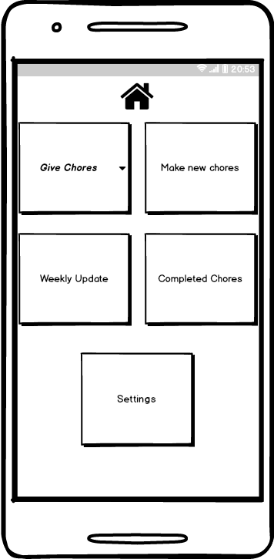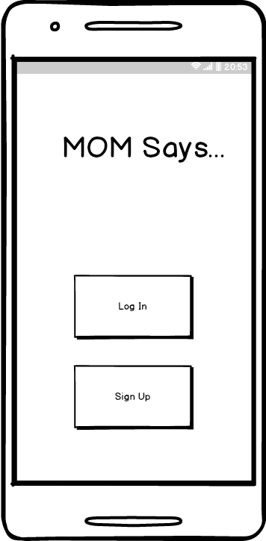

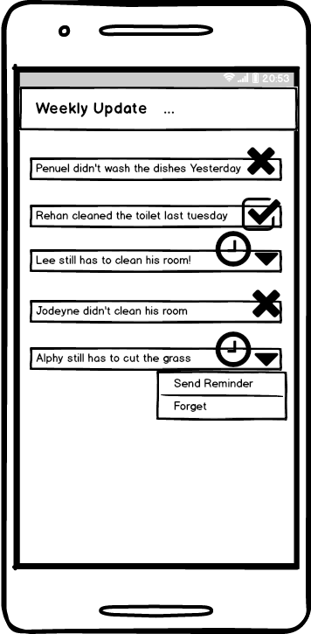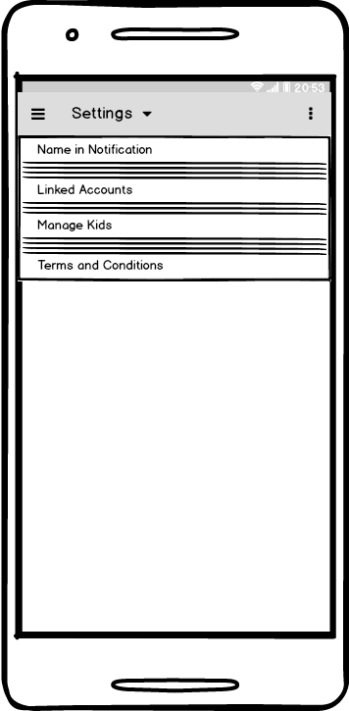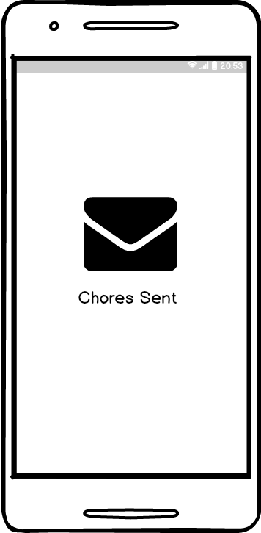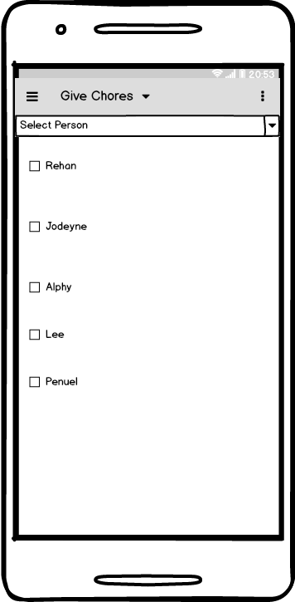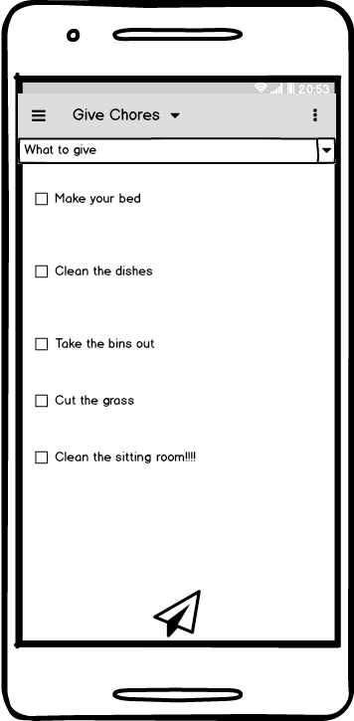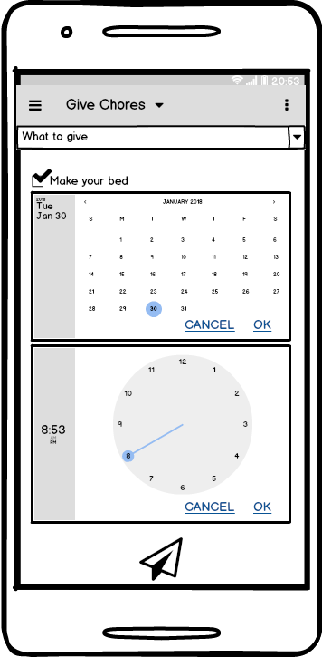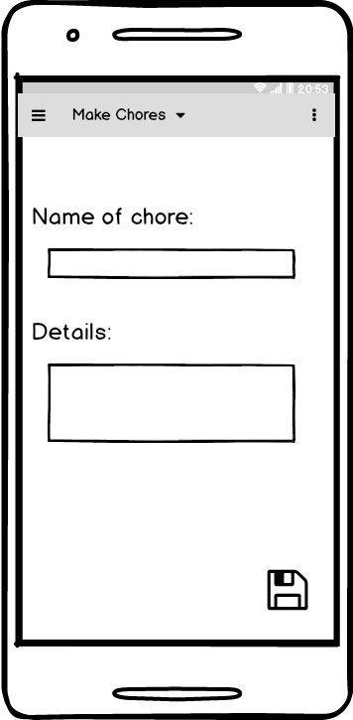

## Project Plan

Our work process involves the use of mix Kanban and Scrum method. It consists of iteration and incremental development, starting from the basic and the main functionality and gradually add the extra features.

Every end of the week (Friday or Saturday), we do a release of what we’ve done during our coding session. We review it and discuss on how we can improve our efficiency and improve our product. We then document our work. After our retrospective session, we then plan for next week work and what we will be working on.

|  |  |
| --- | --- |
| **Task** | **Week** |
| **Requirement Analysis** | **Week 3** |
| ^ UML | Mon, Tue, Wed, Thur, Fri |
| ^ Decide Platform | Mon, Tue, Wed, Thur, Fri |
| ^ Functionalities | Mon, Tue, Wed, Thur, Fri |
| Requirement Analysis Submission | ^ Friday 9th Feb |
|  |  |
| **System Design** | **Week 4** |
| ^ Software Architectural | Mon, Tue, Wed, Thur, Fri |
| ^ Flowchart | Mon, Tue, Wed, Thur, Fri |
| ^ Back-End/Database Design | Mon, Tue, Wed, Thur, Fri |
|  |  |
| **Implementation/ Coding** | **Week 5 to Week 6** |
| ^ GUI mobile | Mon, Tue, Wed, Thur, Fri |
| ^ GUI desktop | Mon, Tue, Wed, Thur, Fri |
| ^ Main Functional Features/ API | Mon, Tue, Wed, Thur, Fri |
| ^ Back-End/ Database Integration | Mon, Tue, Wed, Thur, Fri |
| ^ Unit Testing | Mon, Tue, Wed, Thur, Fri |
| Release & Review & Documentation | Every SATURDAY |
|  |  |
| **Implementation/Coding** | **Week 7** |
| ^ GUI mobile | Mon, Tue, Wed, Thur, Fri |
| ^ GUI desktop | Mon, Tue, Wed, Thur, Fri |
| ^ Main Functional Features/ API | Mon, Tue, Wed, Thur, Fri |
| ^ Back-End/ Database Integration | Mon, Tue, Wed, Thur, Fri |
| ^ Unit Testing | Mon, Tue, Wed, Thur, Fri |
| Release for Prototype & Documentation | Mon, Tue, Wed, Thur, Fri |
|  |  |
| **Mid-Point Presentation** | **Week 8** |
|  |  |
| **Implementation/Coding** | **Week 9 to 11** |
| Review for Improvement | Mon, Tue, Wed, Thur, Fri |
| ^ General Development | Mon, Tue, Wed, Thur, Fri |
| ^ Extra Features/ API | Mon, Tue, Wed, Thur, Fri |
| ^ Additional API | Mon, Tue, Wed, Thur, Fri |
| Unit Testing > Release & Documentation | Mon, Tue, Wed, Thur, Fri |
|  |  |
| **FINAL PHASE & CLOSING PROJECT** | **Week 12** |
| ^ GUI Final Refurbishment | Mon, Tue, Wed, Thur, Fri |
| ^ Final Quality Testing | Mon, Tue, Wed, Thur, Fri |
| ^ Final Release & Documentation | Mon, Tue, Wed, Thur, Fri |
| ^ Ready for Final Presentation | Mon, Tue, Wed, Thur, Fri |
|  |  |
| **PROJECT PRESENTATION** | **Week 13** |

## Summary

* The app is for parents to help them manage and distributes chores/task to their kids.
* No more excuses for the kids as they are notified constantly until they do the chores.
* The reward system motivates to do the chores.
* The app will only run on Android devices for now, but hopefully it will be accessible on IOS and desktop too.

|  |
| --- |
| REFERENCES   * Site visited conducting our Market Research   + <https://play.google.com/store?hl=en> |